Botanical Society of Washington

926th Meeting

Tuesday, 4 October, 2011 at 7:00 P.M

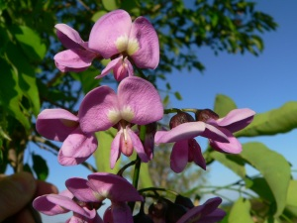 | Dr. Steven Casper  Food and Drug Administration  Ethnobotanist  “Traditional history of use versus modern supplement conditions of use.”
Location: Cathy Kerby Room (Room CE-340)
Smithsonian Institution, National Museum of Natural History
All are Welcome.
As usual, light refreshments will be served.

Pre-meeting dinner: 5:30 P.M. at the Elephant & Castle Pub and Restaurant,
1201 Pennsylvania Ave., N.W., Washington. Phone 202-347-7707. The restaurant is
diagonally across from the Old Post Office Pavilion at 12th and Pennsylvania, a few blocks from the Museum, with Federal Triangle the nearest Metro station, and
Metro Center also nearby.

Let Larry Dorr know if you are coming to the meeting by September 30 so that he can
arrange for badges. DORRL@si.edu

Abstract: People throughout the world have traditionally used plants in ways that create a spectrum
from food to medicine and everything in between. Through millennia, many of these uses have
persevered and, often, in very prescribed ways. However, the current explosion of the dietary
supplement market has created many novel combinations and uses that have no basis in traditional
systems of health.
